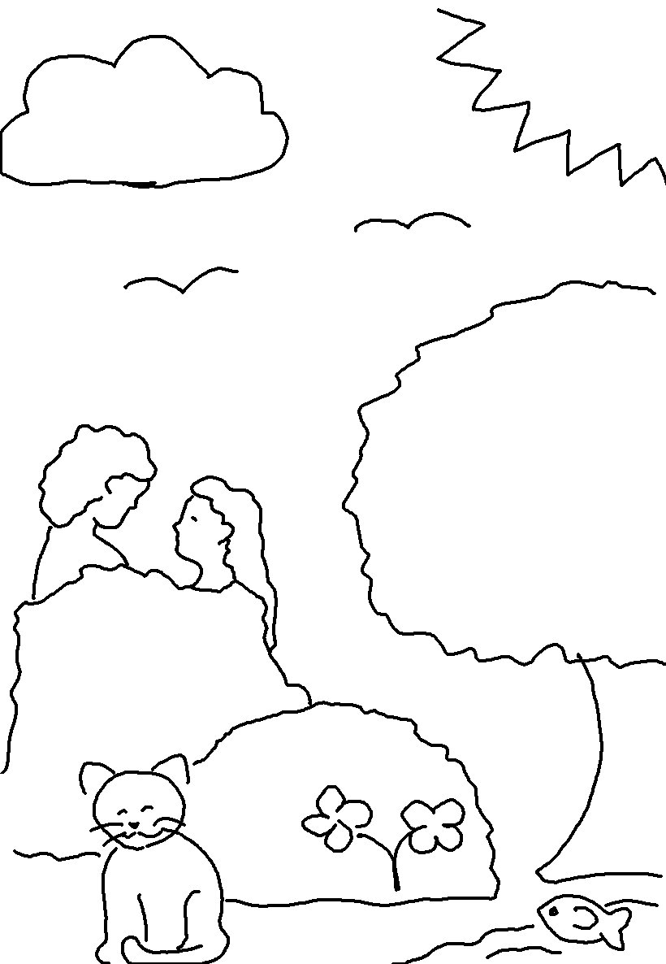
God said, "Let us make _ _ _ _ _ beings in our image, to be like _ _." Genesis 1:26_{NLT}

